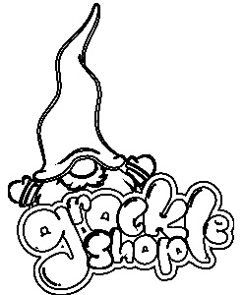
Board Number:
(For multiple orders only)

Monopoly Board Personalisation Form

Street Colour/Name | Street Value (£/$) | Personalisation Name
 | 60
Community Chest | N/A | N/A
 | 60
Income Tax | PAY 200
Train Station | 200
 | 100
Chance | N/A | N/A
 | 100
 | 120
Jail/Just Visiting | N/A | N/A
 | 140
Electric Company | 150
 | 140
 | 160
Train Station | 200
 | 180
Community Chest | N/A | N/A
 | 180
 | 200
Free Parking | N/A
 | 220
Chance | N/A | N/A
 | 220
 | 240
Train Station | 200
 | 260
 | 260
Water Works | 150
 | 280
Go To Jail | N/A | N/A
 | 300
 | 300
Community Chest | N/A | N/A
 | 320
Train Station | 200
Chance | N/A | N/A
 | 350
Super Tax | Pay 100
 | 400

Board Name:

Player 1 Name:

Player 2 Name:

Player 3 Name:

Player 4 Name:

Notes

- Train stations if not personalised will be listed as UK station or US station. Please state “US” or “UK” in the personalisation box if you don’t have a specific personalisation request.
- If there are less than 4 names for personalisation, please leave blank and we will engrave the wallet with “Guest One”, “Guest Two”, “Guest 3”. If there are 0 names for personalisation, we will personalise the player wallets with “Player 1-4”
- Please double check all spelling before submission as all boards will be made as per submitted spelling. Any changes to spelling once the board has been made will result in additional cost.

Customer Name

